Smart Policing in Detroit, MI, U.S.A. using Foursquare API

# Introduction

According to the United States Federal Bureau of Investigation’s Uniform Crime Report in 2017, Detroit ranked among the top three most dangerous cities to live in in the United States, in terms of the rate of crimes reported (1). Although the city has recovered its economic status as a metropolis after the economic recession of 2008-2009, high rates of violent crimes still plagues it. With limited resources to spend on public safety, Detroit faces the problem of how to most efficiently organize policing (i.e., patrols, officer stations) to maximize its effects on curbing the rate of violent crimes and enhance public safety.

To answer this complicated problem, the city of Detroit could begin by focusing on the geography of crime: where crime occurs. Are there hotspots of criminal activity in the city? Where would people be found near these crime hotspots? Are there similarities between crime locations with other crime locations in the city? These three questions, if answered satisfactorily, could provide significant insights into the patterns of criminal activity in Detroit and aid in the efficient allocation of police and public safety resources such as stations, patrols, and 9-1-1 emergency kiosks. For example, by finding the hotspots of criminal activity, permanent police stations or 9-1-1 dial booths could be built in the vicinity to enhance public safety. Knowing the locations where large amounts of people could likely be found near these crime hotspots makes the delivery of emergency information and services faster. Understanding the similarities between areas of crimes in terms of features in the geographic vicinity helps police patrol more effectively. Using data science to investigate the geography of crime in Detroit, the city could begin to develop insights into the patterns of criminal activity in the city and boost Detroit’s police operations and public safety efforts.

# Data

## Data Sources

Datasets on public safety collected by the City of Detroit constitutes a significant portion of this data analysis effort. In particular, a portion of the “All Crime Incidents, December 6, 2016-Present” page on the City of Detroit Open Data Portal (2) will be used. The City of Detroit’s crime data can be extracted either via downloading the entire dataset in a spreadsheet format, or via GeoJSON/JSON. To save computing power and time, as well as to provide the most current thus relevant information, only data from the year 2019 will be considered in the analysis. The City of Detroit’s “All Crime Incidents” dataset contains such information as the address of the crime reported, the type of offense, the neighborhood, and the latitude and longitude. The City of Detroit’s crime data by itself could provide an insightful preliminary data exploratory analysis into the location of potential criminal hotspots based on geographic information, using a machine learning algorithm such as DBSCAN. This data analysis could aid in directing public safety efforts and service delivery.

In addition to the City of Detroit’s data, this project will also query Foursquare API for the popular/recommended venues near the recorded crimes’ geographic vicinity. With the Foursquare API data, we could discover similarities between locations where crime has occurred, based on what is around the crime locations, using clustering algorithms such as K-mean clustering on the Foursquare API data. This additional analysis also could help direct and tailor public safety resources and services to fit the features of locations prone to criminal activities.

## Data Cleaning

The criminal record dataset downloaded from the City of Detroit Open Data Portal contains 21752 instances of crimes with 25 features in its raw format. Due to the nature and scope of this data analysis project, I chose to select only 4 features to inform subsequent data analysis: category of crime, neighborhood, latitude, and longitude. For this project, data cleaning was an iterative process. With new insights I gathered from data analysis, I further cleaned the data. For example, initially, I chose 10% of the entire data set (2000 crime records) to use for subsequent data analysis. However, after failing to create a folium map with markers, I realized that it is impossible to visualize the data on the folium map with that many markers. So, I decreased the portion of the data set used to ~1%, 200 crime records sampled at random from the entire dataset, for easier visualization and analysis. There were some instances where the latitude and longitudes were not recorded. These crime records were removed.

# Methodology:

## Exploratory Data Analysis

To have a preliminary understanding of the criminal activity patterns in the city of Detroit, I plotted the locations of criminal activities on a folium map as a form of exploratory data analysis. This step ensures that the cleaned dataset could be correctly visualized and provides an easy first-glance at the crime distribution in Detroit on a map. Observations could be made here with the naked eye to inform machine learning in subsequent steps.

## Clustering using DBSCAN

Density-based spatial clustering of applications with noise (DBSCAN) is an unsupervised machine learning algorithm that clusters data points based on the distribution density. This technique is particularly suitable for understanding the distribution of data points in a geospatial context as it has the advantage of 1) being able to discover regions of high density, 2) non-linearly separable clusters (which in this case is not really needed) and importantly, 3) having no need of a previously defined parameter such as the K constant in K-means clustering. For the above reasons, I chose DBSCAN in Python to analyze the crime dataset in Detroit to discover crime hotspots. The criminal activities were then plotted on the folium map of Detroit and colored to identify their respective clusters.

## Clustering using Foursquare API

Foursquare API contains an enormous volume of geospatial data and, importantly, consumer/human data that reflects human activities. Combining Foursquare API data with data from the City of Detroit public safety data has the benefit of providing an additional layer of information and aiding in the discovery of new underlying patterns. I queried the Foursquare API, retrieved the recommended venues list by using neighborhoods and locations data from the criminal activity dataset to discover what kind of venues are nearby the locations where crimes occurred. These recommended venues were then sorted and merged with the original dataset from the City of Detroit to add additional information to each criminal activity data point on the top 10 most common venues near its vicinity, according to Foursquare API user data.

Additionally, I used K-means clustering to cluster the crime locations based on the most common venues in their vicinity. I chose K-means clustering because it is robust and straightforward to implement and provides another machine learning algorithm to analyze the dataset, other than the DBSCAN technique already employed. To discover the optimal K for clustering, I used the “elbow method” to find the local minimum for distortion. Finally, I plotted the criminal activity locations on a folium map of Detroit, while coloring the data points based on their K-means clustering cluster number, to discover patterns in criminal activities.

# Results:

## The Geographic Distribution of Criminal Activities

The map below shows the geographic distribution of 200 criminal activities recorded in the City of Detroit’s public safety dataset. Despite not having undergone clustering analysis, the distribution does show certain regions of very high criminal activities. The downtown region (orange circled region), close to the Canadian border, an area in the East by the municipal airport (yellow circled region), and an area in the West bounded loosely by M102, M39, and I96 (green circled region).

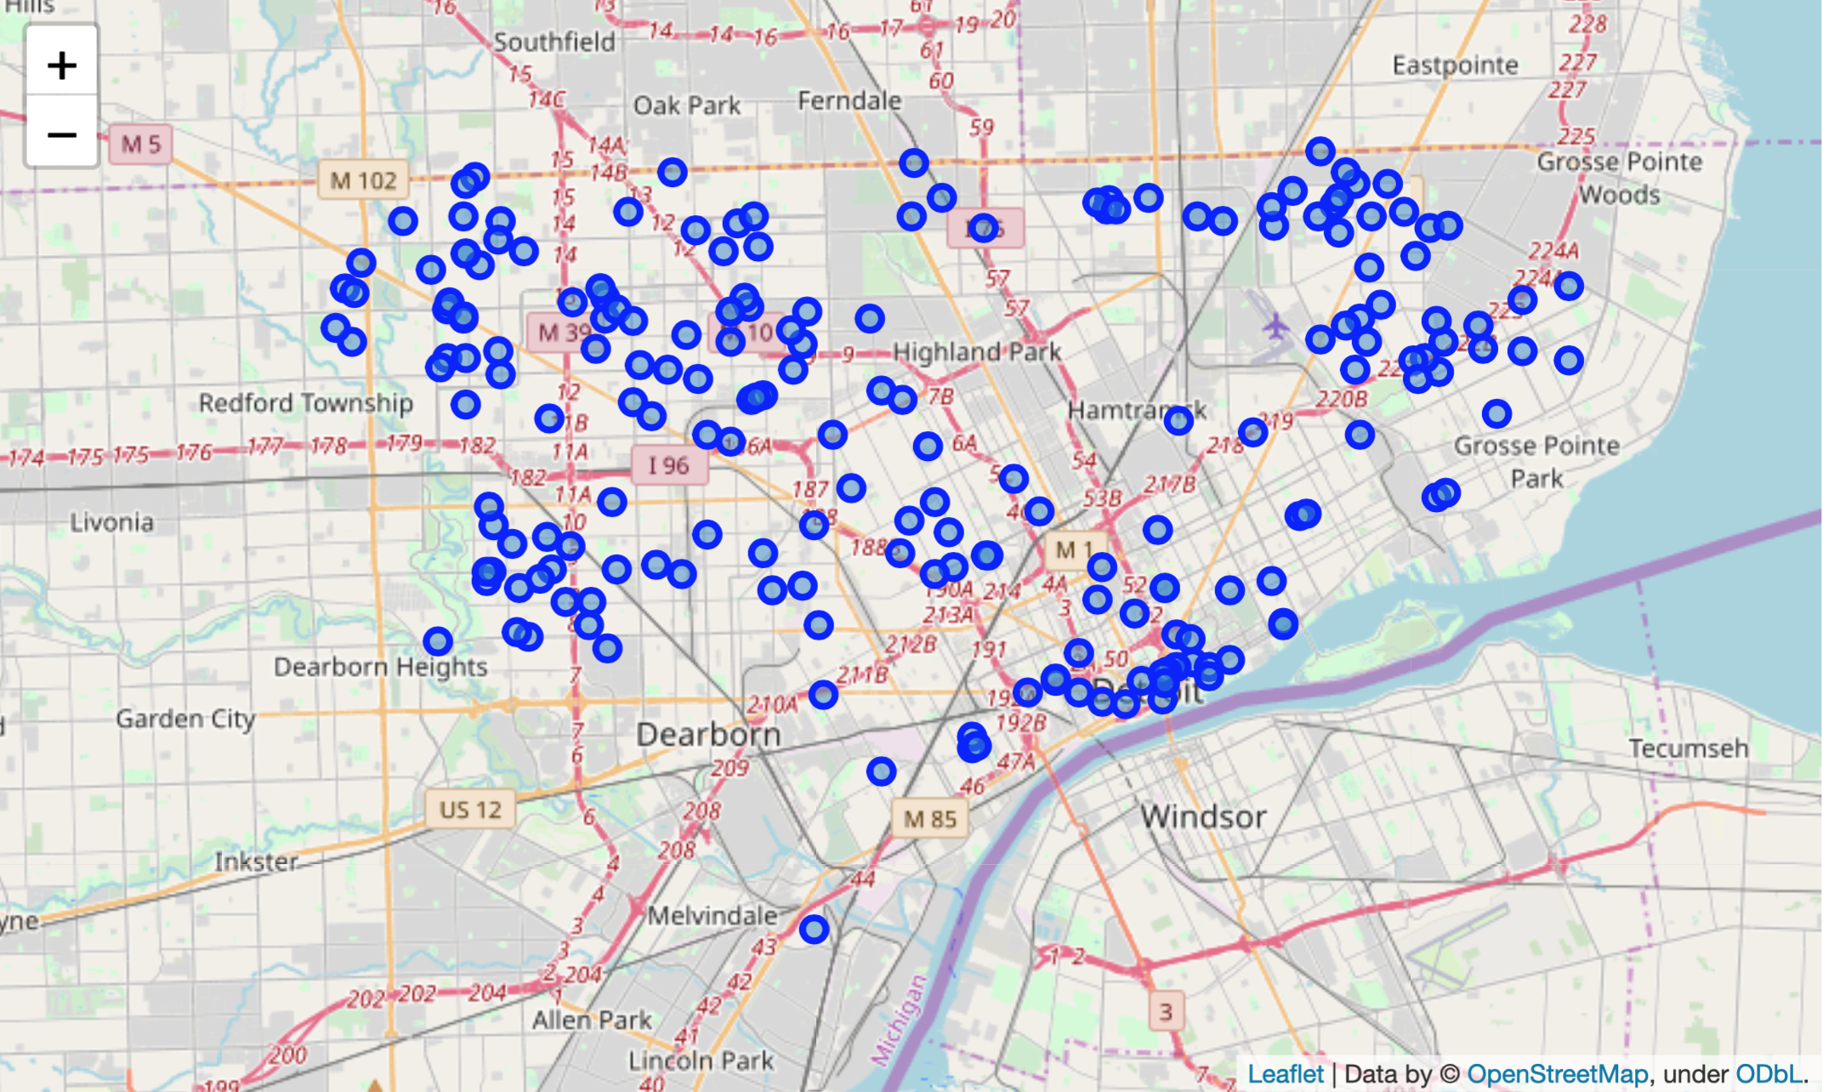

## Understanding the Distribution of Criminal Activities using DBSCAN

The map below shows the clustering of 200 criminal activity records in Detroit using the machine learning algorithm DBSCAN. From this result, we could see that the exploratory data analysis did yield a very similar result. The DBSCAN clarified the existence of three distinct areas of high criminal activities in the city of Detroit, which can be referred to as crime hotspots. The red region is in the Northwestern end of the city, in a region bounded by M 102, I 96, and Highland Park. The green region is in the Northeastern end of the city, bounded by the municipal airport, Eastpointe, Grosse Pointe Woods, and Grosse Pointe Park. This green region appears also to be in the vicinity of many large manufacturing plants and companies such as GM and Chrysler (confirmed with Google Maps). The blue region constitutes both the inner city, downtown area of Detroit, as well as locations close to Dearborn and Dearborn Heights.

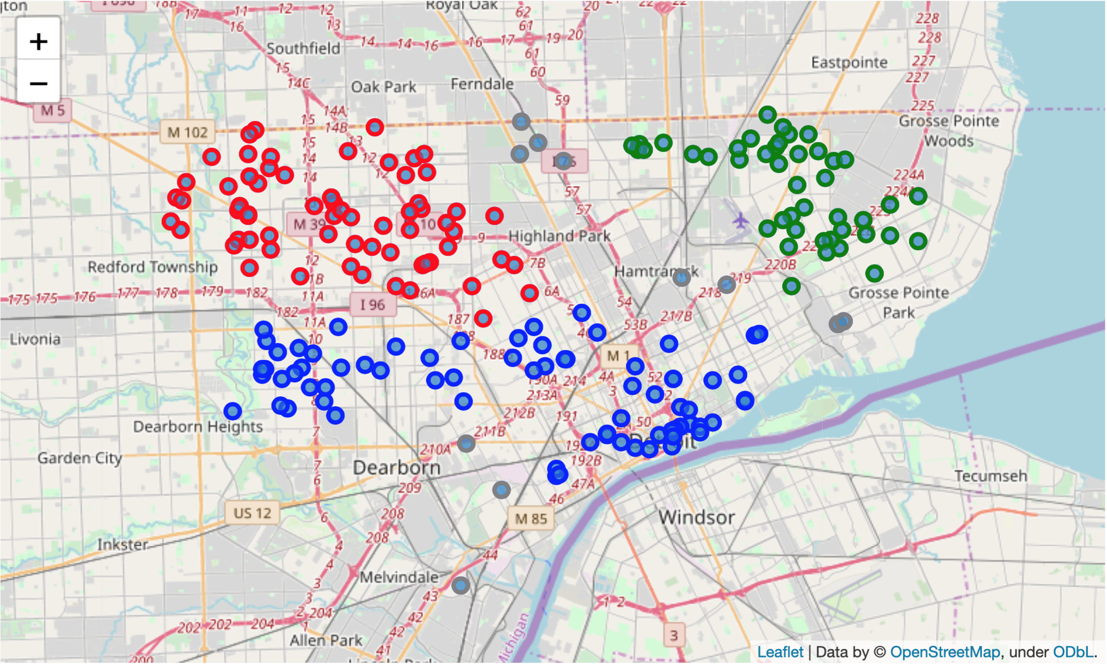

## K-means Clustering of Foursquare API Data

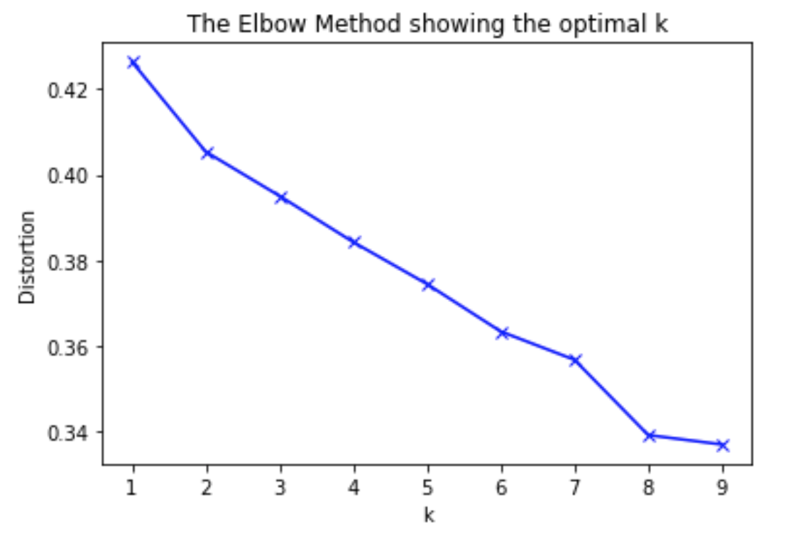

To successfully use K-means clustering, I first determined the optimal K constant—how many clusters there should be to have minimal distortion, using the “elbow method.” I discovered that the optimal number of clusters to minimize distortion is 8. Therefore, I fitted the Foursquare API data into a K-means clustering algorithm with K = 8.

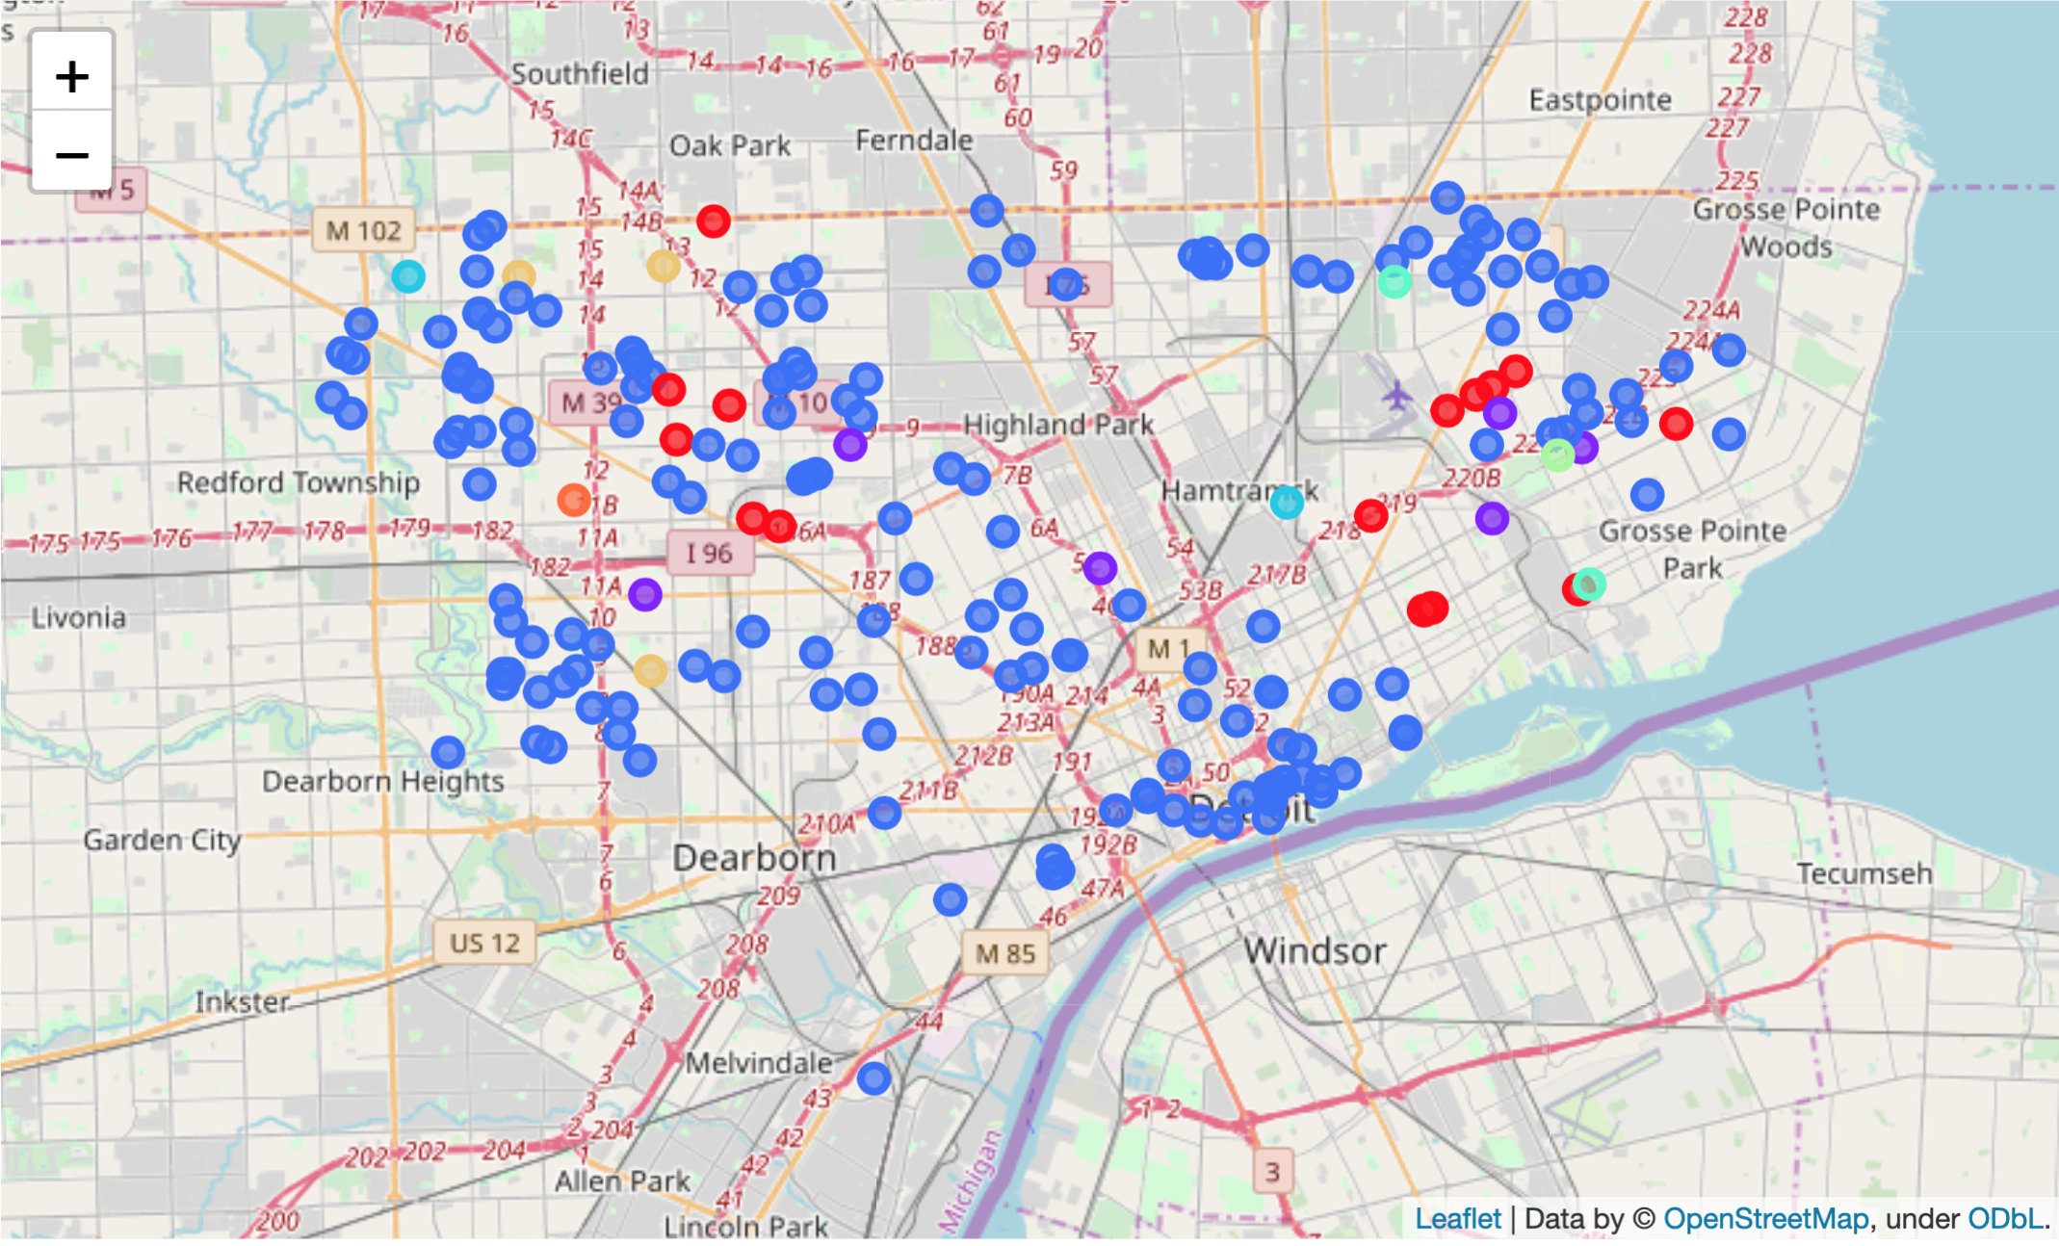

The results of the clustering algorithm yielded eight clusters. I assigned each of the clusters a color and plotted the City of Detroit’s criminal data with their colors onto a folium map of Detroit to visualize criminal activity. The above graph results from that effort. We could see that the majority of the criminal activities belong in the cluster painted blue (Cluster 2). Interestingly, some other crime locations are clustered in the same cluster despite their apparent geographic distance, such as those colored red, appearing in both the Western and Eastern end of the city. These data points cross the boundaries of the clusters formed by the DBSCAN algorithm.

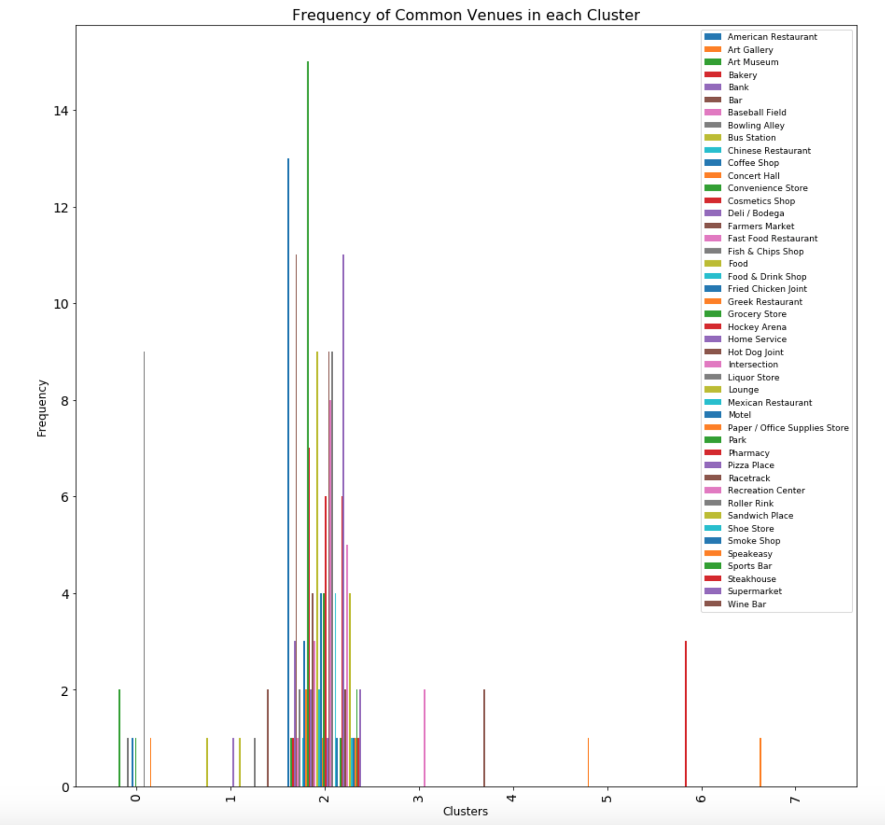

To discover the patterns behind the K-means clustering, I created a bar graph (found above) and a list (in the Appendix section; top appearing common venues highlighted in yellow) to understand the characteristics of these clusters. I discovered the most common venues found around each of the clusters and summarized the findings in the table below:

|  |  |
| --- | --- |
| Cluster | Most Common Venue(s) |
| 0 | Liquor store |
| 1 | Wine bar |
| 2 | Convenience store, American restaurant, pizza place, bar |
| 3 | Intersection |
| 4 | Bar |
| 5 | Concert hall |
| 6 | Cosmetics shop |
| 7 | Art gallery |

# Discussion and Recommendations

The data analysis conducted showed that the crimes occurring in the city of Detroit could be found concentrated in three regions: the downtown area, the Northwestern end of the city, and the Northeastern part of the city. In identifying these criminal activity hotspots using the DBSCAN algorithm, I have provided the city of Detroit with an efficient way to organize their public safety resources based on the geographic density of crime in the city. My recommendation to the city of Detroit’s public safety agents based on the DBSCAN clustering of the geographic density of crime is to increase the delivery and maintenance of public safety resources and services, such as police patrols, 9-1-1 emergency kiosks, and public safety information, in these three areas of high criminal activity to combat crime and enhance public safety.

Using additional data from Foursquare API, I provided another means to examine criminal activity patterns in the city of Detroit. I used the K-means clustering algorithm to cluster criminal activity data points not by their geographic distribution but by their similarities based on Foursquare API user data on recommended venues near each criminal record’s locations. The resulting analysis showed where each crime occurred in relation to what kind of venues are located near it. Two interesting observations emerge: 1) the majority of criminal activities occurred near areas where there are convenience stores, American restaurants, bars, and pizza places (see Appendix or above map, Cluster 2). 2) a portion of criminal activities occur near liquor stores (see Appendix or above map, Cluster 0). These two patterns, from K-means clustering, suggest to the city of Detroit additional locations to increase the delivery and maintenance of public safety resources and services. My recommendation, following the patterns emerging from this analysis, is to increase public safety resources and services such as police patrols, 9-1-1 emergency kiosks, and public safety information dissemination around convenience stores, restaurants, bars, and liquor stores. Selectively targeting these locations will maximize the efficacy of public safety efforts and help curb criminal activity the most.

# Conclusions

The city of Detroit is notorious for its high crime rates. Every day, the city of Detroit’s public safety agents face the problem of how to most efficiently organize public safety resources to maximize their effects on curbing crime rates and enhancing public safety. Using data from the City of Detroit Open Data Portal on public safety and Foursquare API, I discovered the existence of criminal hotspots—locations where crimes occur at the highest rate, in the city of Detroit, as well as some common venues near the vicinity of crime locations. The identification of these crime features and patterns provide a means for Detroit’s public safety agents to more effectively and efficiently deliver and maintain their public safety resources and services, such as police patrols, information dissemination, and emergency protocols. In the future, other cities plagued by high rates of crime could follow suit and use data analysis similar to the one performed in this project to identify their patterns of crime. Moreover, robust data analysis using a larger dataset for the city of Detroit could perhaps yield even more insights and trends of criminal activity.

# Appendix—the list of the 1st common recommended venue

K-means Cluster Labels 1st Most Common Venue

0 Convenience Store 2.0

Fish & Chips Shop 1.0

Fried Chicken Joint 1.0

Grocery Store 1.0

Liquor Store 9.0

Paper / Office Supplies Store 1.0

1 Bus Station 1.0

Home Service 1.0

Lounge 1.0

Roller Rink 1.0

Wine Bar 2.0

2 American Restaurant 13.0

Art Museum 1.0

Bakery 1.0

Bank 3.0

Bar 11.0

Baseball Field 1.0

Bowling Alley 2.0

Chinese Restaurant 1.0

Coffee Shop 3.0

Concert Hall 2.0

Convenience Store 15.0

Cosmetics Shop 7.0

Deli / Bodega 2.0

Farmers Market 4.0

Fast Food Restaurant 3.0

Food 9.0

Food & Drink Shop 2.0

Fried Chicken Joint 4.0

Greek Restaurant 1.0

Grocery Store 4.0

Hockey Arena 6.0

Home Service 1.0

Hot Dog Joint 9.0

Intersection 8.0

Liquor Store 9.0

Mexican Restaurant 4.0

Motel 1.0

Park 1.0

Pharmacy 6.0

Pizza Place 11.0

Racetrack 2.0

Recreation Center 5.0

Sandwich Place 4.0

Shoe Store 1.0

Smoke Shop 1.0

Speakeasy 1.0

Sports Bar 2.0

Steakhouse 1.0

Supermarket 2.0

3 Intersection 2.0

4 Bar 2.0

5 Concert Hall 1.0

6 Cosmetics Shop 3.0

7 Art Gallery 1.0

# References:

1. <https://www.usatoday.com/picture-gallery/travel/experience/america/2018/10/17/25-most-dangerous-cities-america/1669467002/>
2. <https://data.detroitmi.gov/datasets/all-crime-incidents-december-6-2016-present/data>